**Assignment -1**

Python Programming

|  |  |
| --- | --- |
| Assignment Date | 19 September 2022 |
| Student Name | K .POOJA |
| Student Roll Number | 211419104191 |

**Question-1:**

1. Split this string

|  |
| --- |
| **Solution:** |
|  | s = "Hi there Sam!"  print(s.split()) |
|  |  |
|  |  |
|  |  |
|  |  |
|  |  |
|  |  |
|  |  |
|  |  |

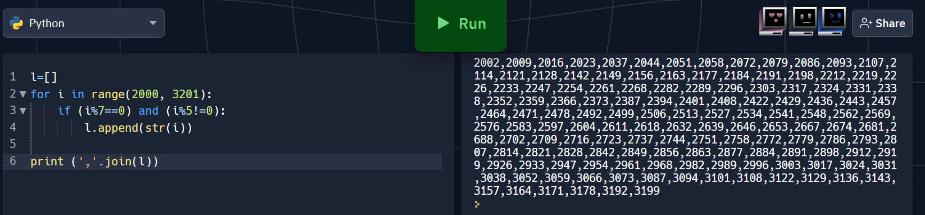

**Question-2:**

## 2. Use .format() to print the following string.

### Output should be: The diameter of Earth is 12742 kilometers.

|  |
| --- |
| **Solution:** |
|  |  |
|  | planet = "Earth"  diameter = 12742  print(f"The diameter of {planet} is {diameter} kilometers.") |
|  |  |
|  |  |
|  |  |
|  |  |
|  |  |
|  |  |

**Question-3:**

3. In this nest dictionary grab the word "hello"

|  |
| --- |
| **Solution:** |

d = {'k1':[1,2,3,{'tricky':['oh','man','inception',{'target':[1,2,3,'hello']}]}]}

print(d['k1'][3]["tricky"][3]['target'][3])